CSC 3210

Computer Organization and Programming

Lab 8

Answer Sheet

Student Name: **Rafid Shaon**

Section: 06 / CRN: 18119 - Bikram

Lab 8(a)

Debug through each line of instructions.

Take screenshot that includes code and register window.

Record the register content.

and explain the register contents.

Code:

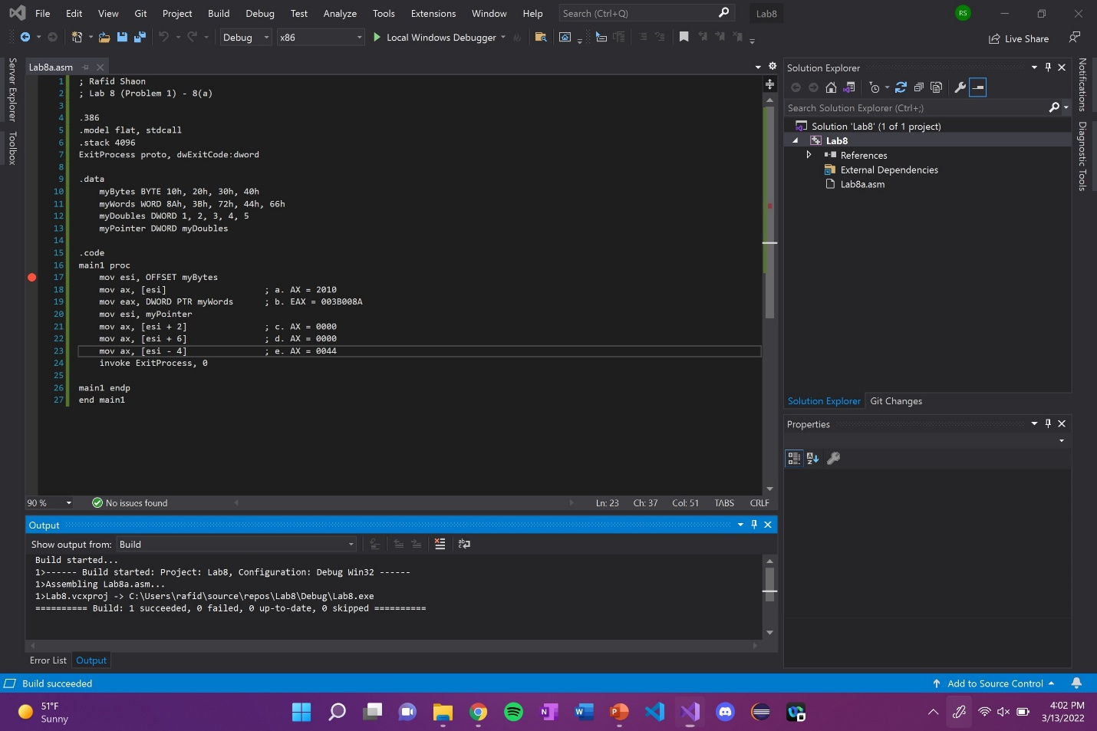

Line number: 17

Instruction: mov esi, OFFSET myBytes

Register values: ESI = 008D4000

Screenshot: 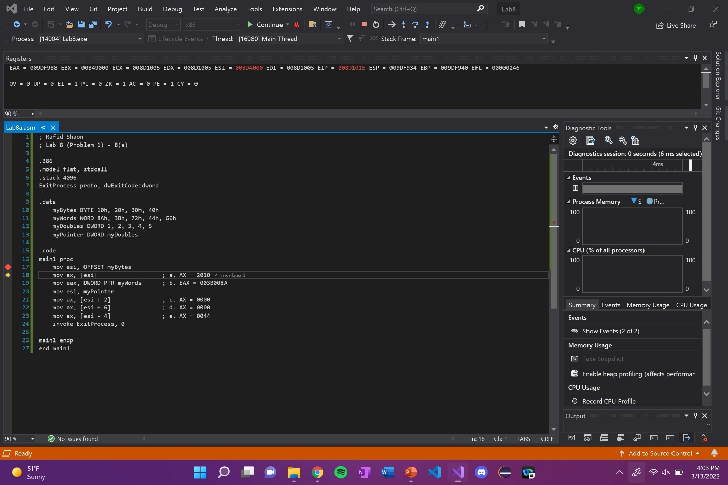

Explanation: N/A

Line number: 18

Instruction: mov ax, [esi]

Register values: EAX = 009D2010

Screenshot: 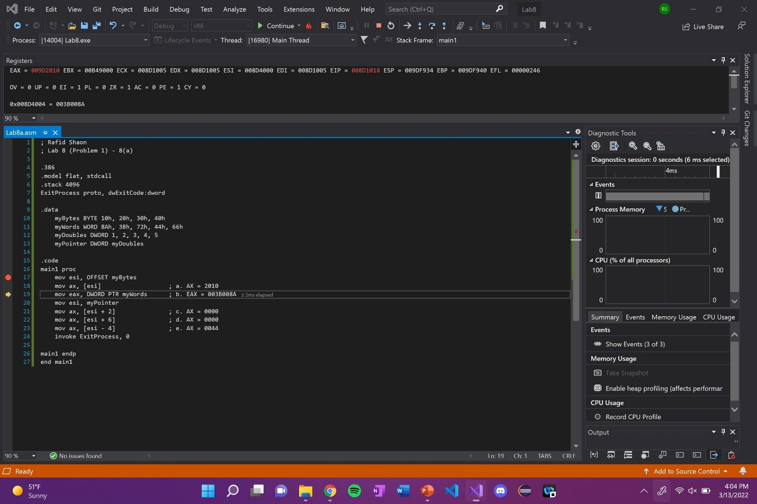

Explanation: EAX register is 32-bit long with a signed integer variable. The register is updated

with 2010 when the first element in ESI is moved to AX.

Line number: 19

Instruction: mov eax, DWORD PTR myWords

Register values: EAX = 003B008A

Screenshot: 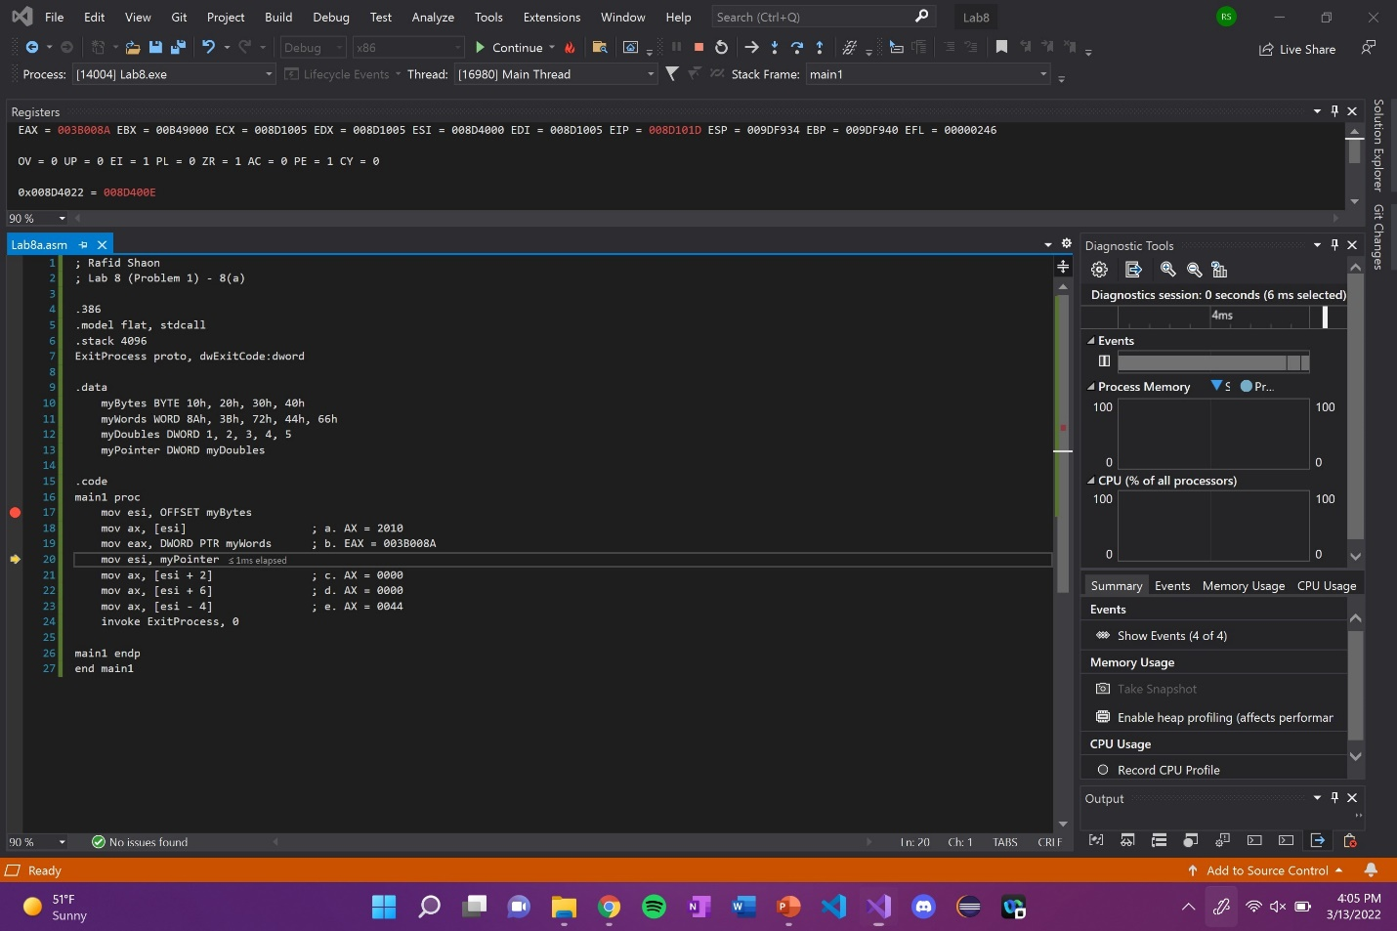

Explanation: EAX register is updated with 003B008A.

Line number: 20

Instruction: mov esi, myPointer

Register values: ESI = 008D400E

Screenshot: 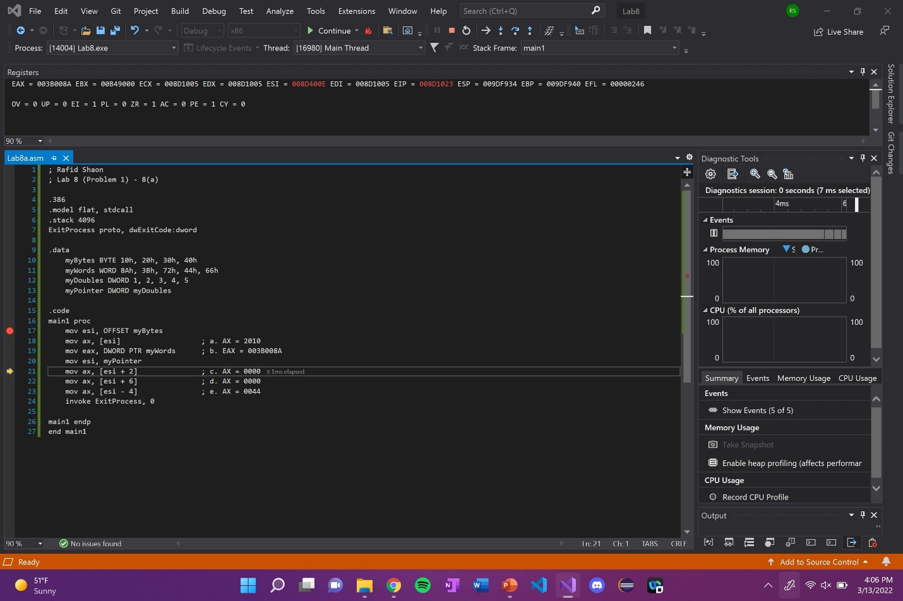

Explanation: N/A

Line number: 21

Instruction: mov ax, [esi + 2]

Register values: EAX = 003B0000

Screenshot: 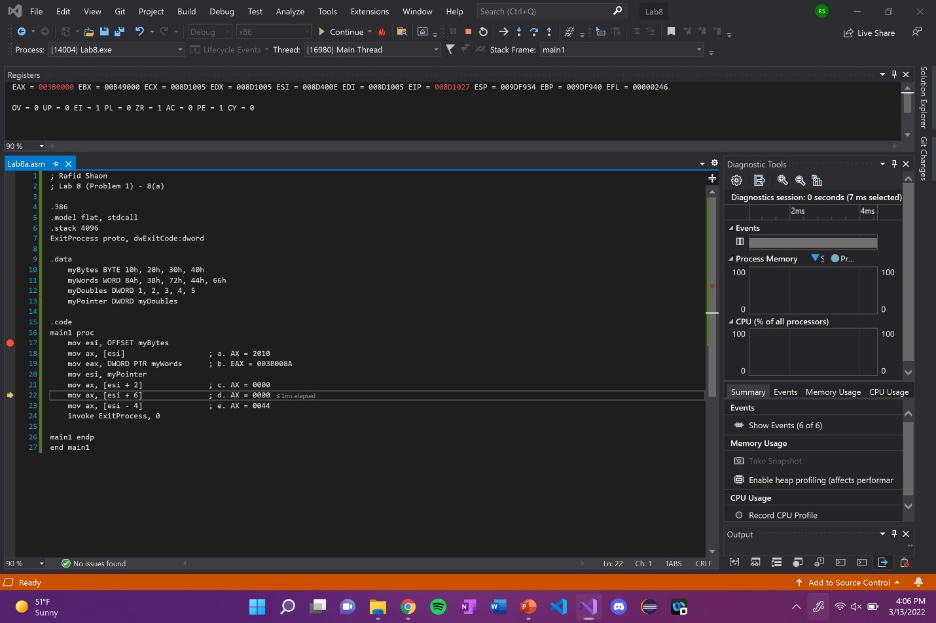

Explanation: EAX register is updated with 0000 in ax when ESI + 2 is moved to AX.

Line number: 22

Instruction: mov ax, [esi + 6]

Register values: EAX = 003B0000

Screenshot: 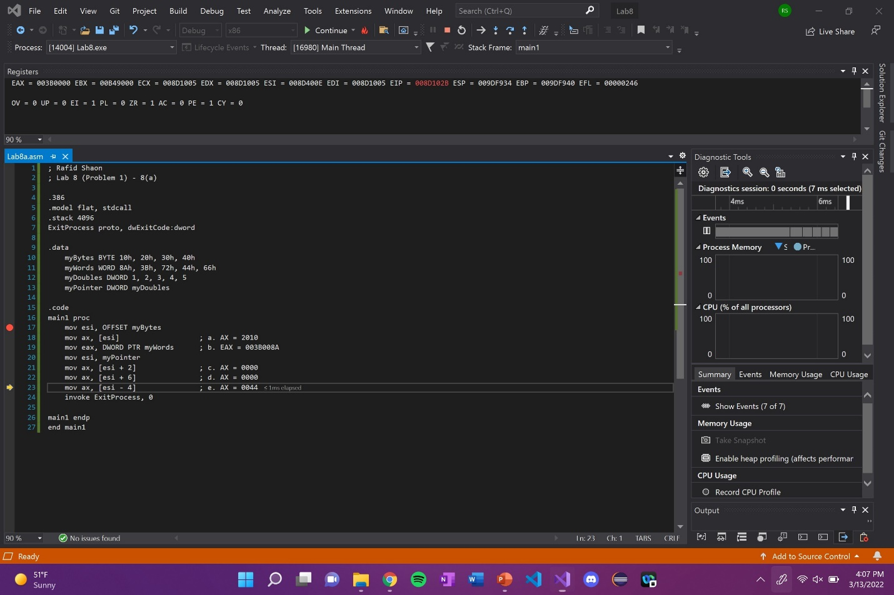

Explanation: Nothing has changed in the EAX register when ESI + 6 is moved to AX.

Line number: 23

Instruction: mov ax, [esi - 4]

Register values: EAX = 003B0044

Screenshot: 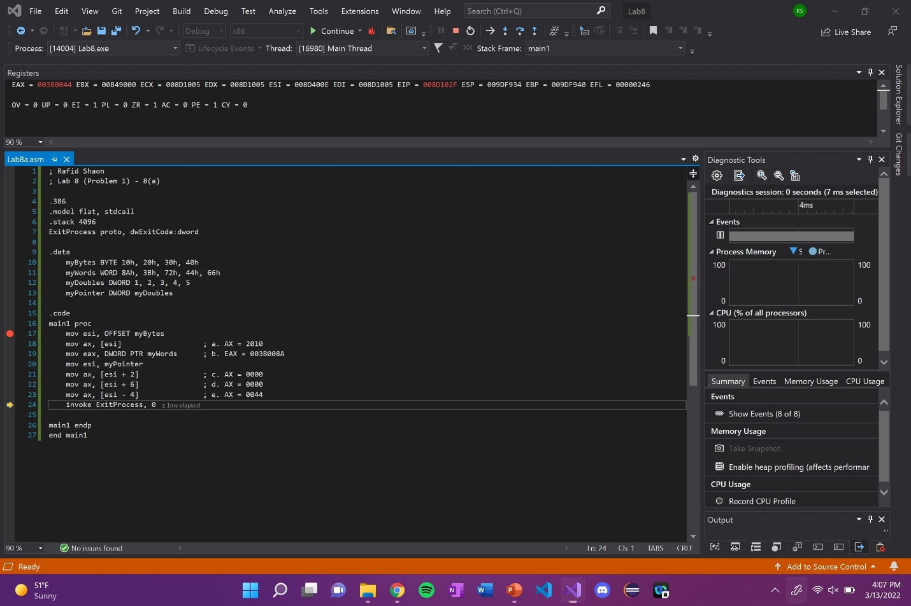

Explanation: EAX register is updated with 0044 when ESI - 4 is moved to AX.

(Copy this format as needed)

Lab 8(b)

Debug through each line of instructions.

Take screenshot that includes code and register window.

Record the register content.

and explain the register contents.

Code: 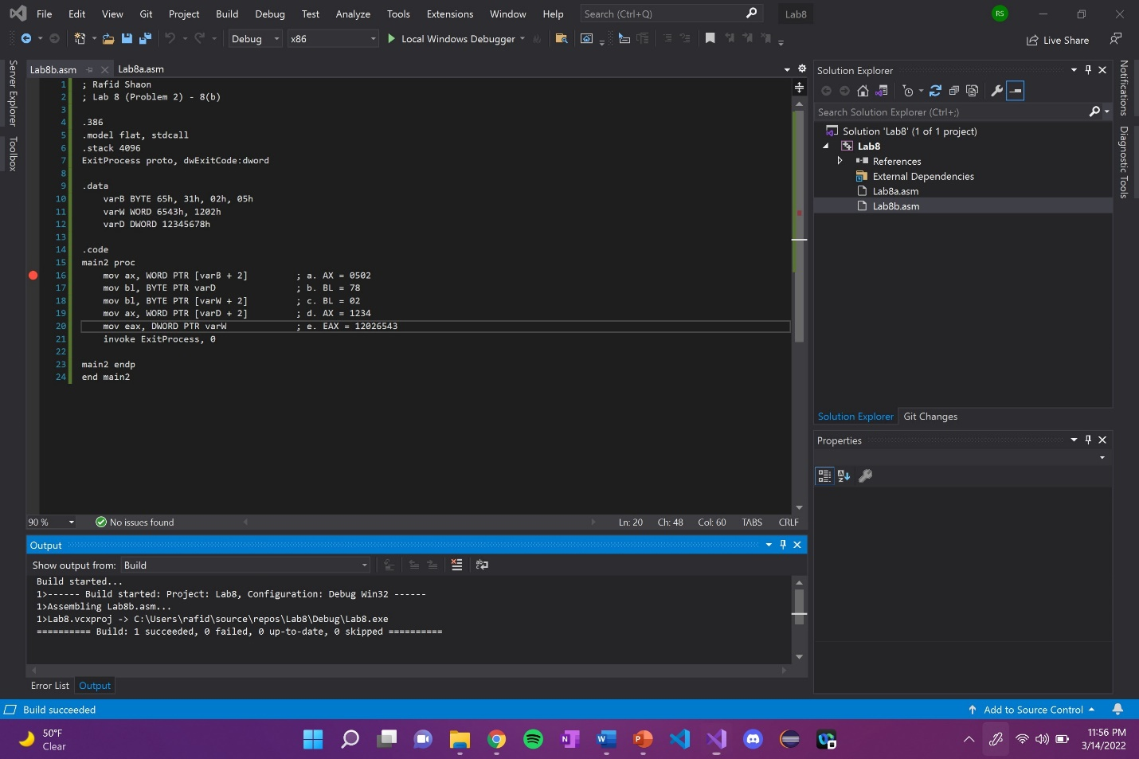

Line number: 16

Instruction: mov ax, WORD PTR [varB + 2]

Register values: EAX = 00EF**0502**

Screenshot: 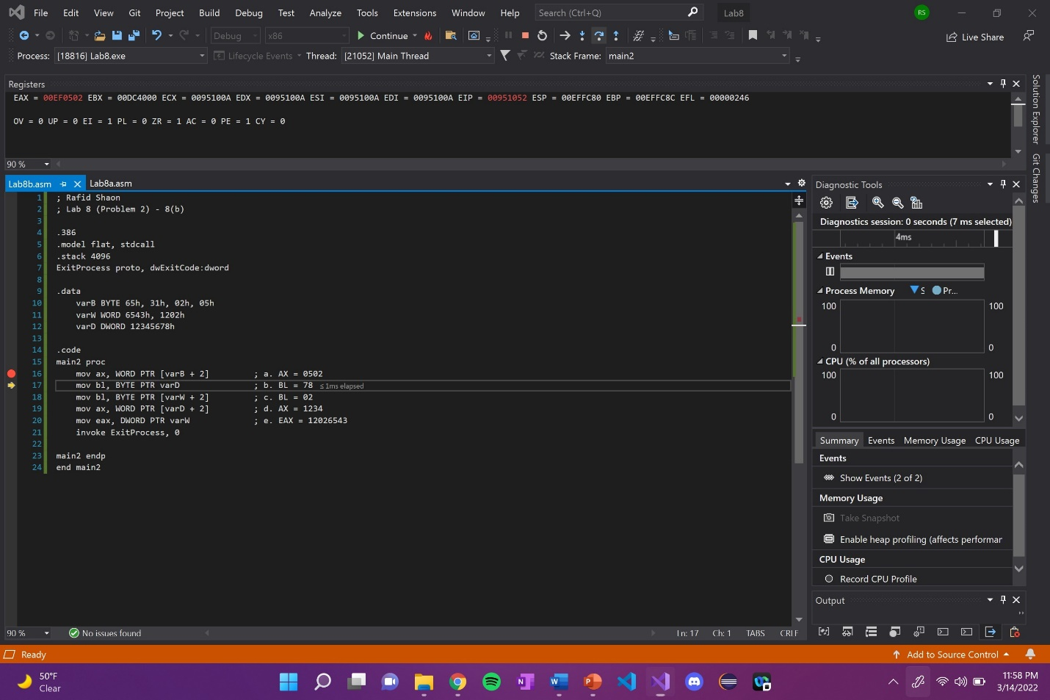

Explanation: AX in EAX register is updated with 0502.

Line number: 17

Instruction: mov bl, BYTE PTR varD

Register values: EBX = 00DC40**78**

Screenshot: 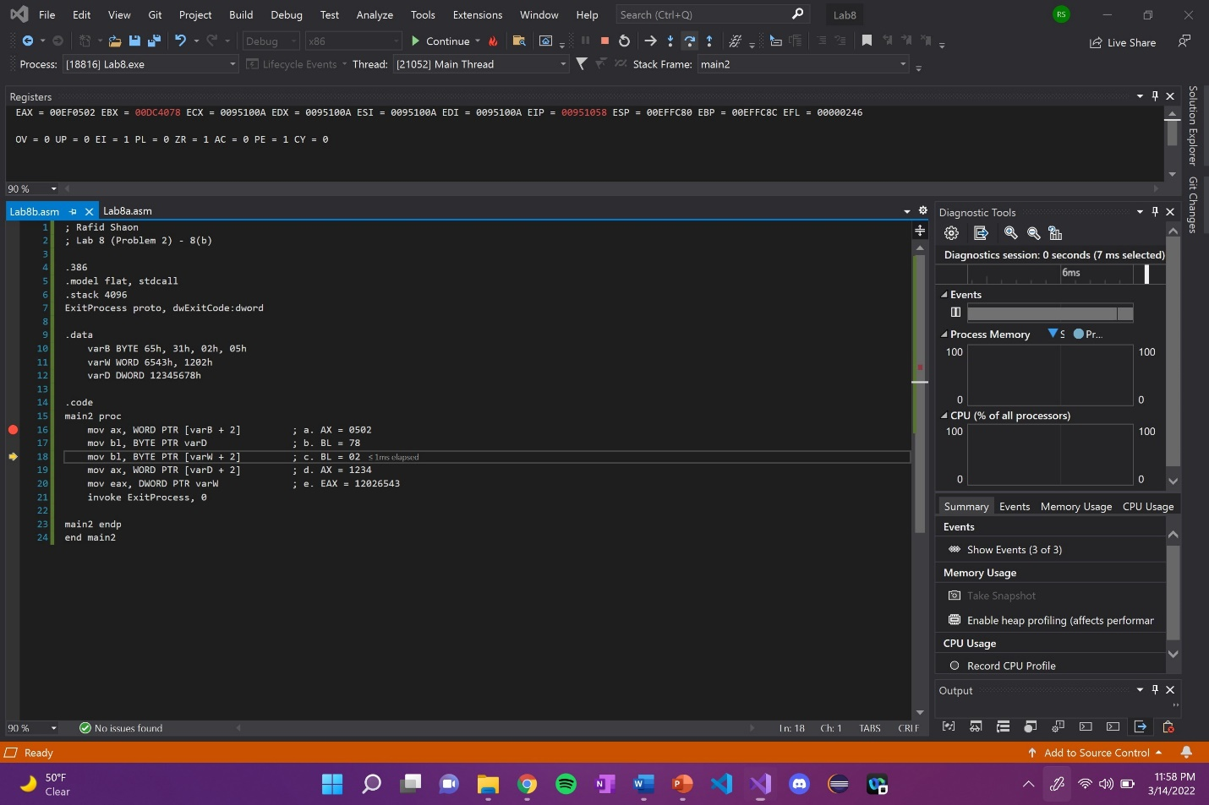

Explanation: BL in EBX register is updated with the last 2 numbers of varD (123456**78**h).

Line number: 18

Instruction: mov bl, BYTE PTR [varW + 2]

Register values: EBX = 00DC40**02**

Screenshot: 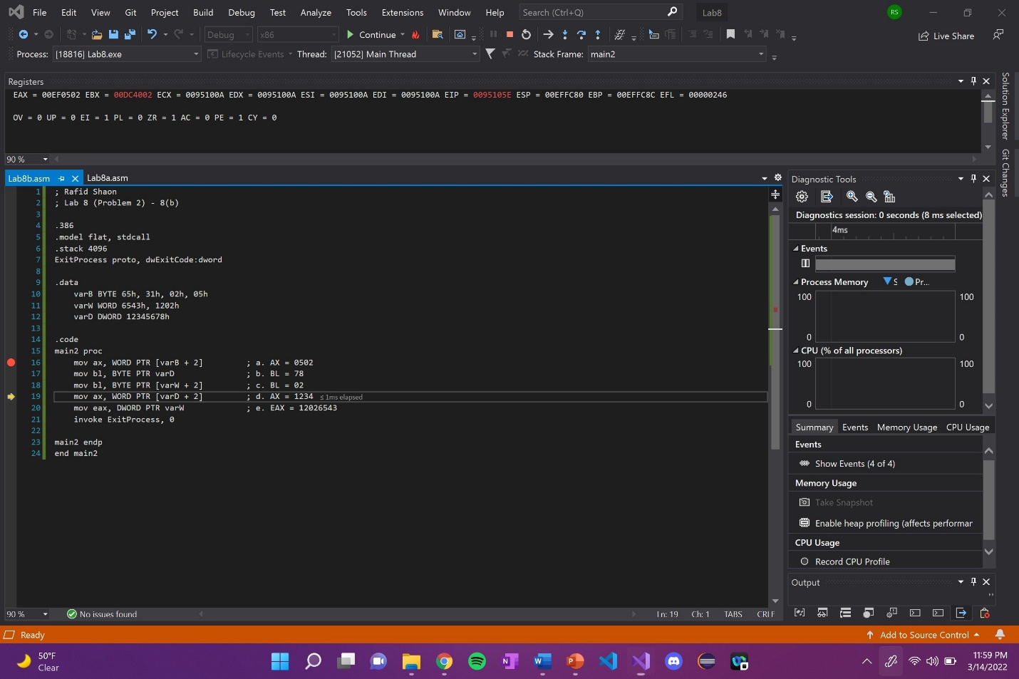

Explanation: BL in EBX register is updated with the last two numbers of the second element in varW (1202h).

Line number: 19

Instruction: mov ax, WORD PTR [varD + 2]

Register values: EAX = 00EF**1234**

Screenshot: 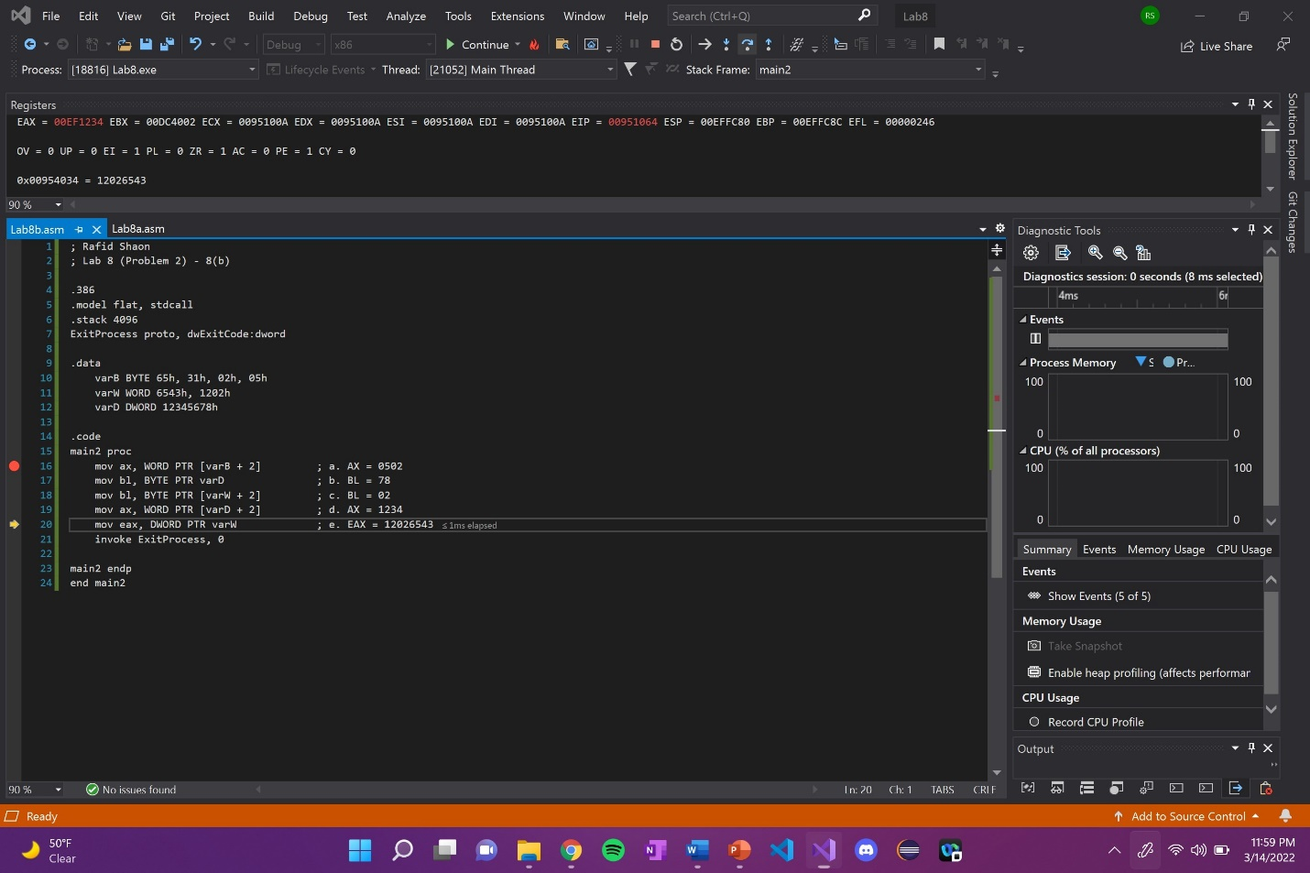

Explanation: AX in EAX register is updated with the first 4 numbers of the second element in varD (**1234**5678).

Line number: 20

Instruction: mov eax, DWORD PTR varW

Register values: EAX = 12026543

Screenshot: 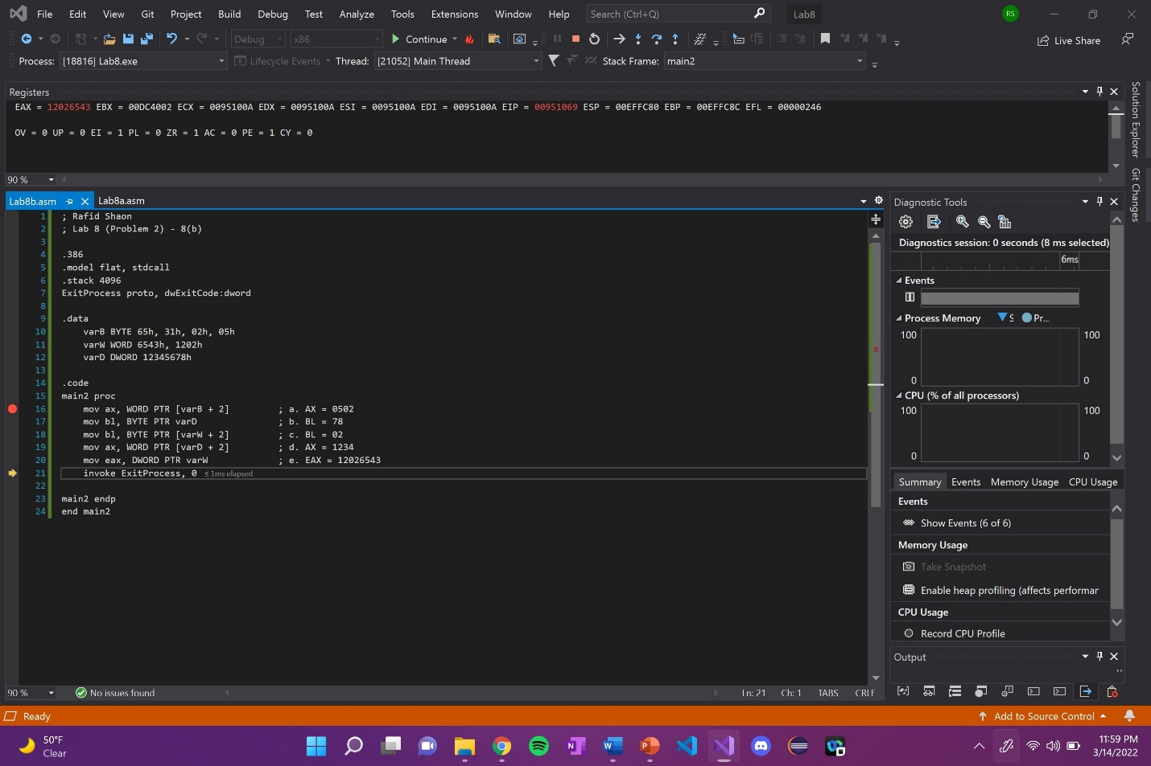

Explanation: EAX register is updated with varW, but in descending order. 1202 is the first half, and 6543 is the second half of the register.

(Copy this format as needed)

Lab 8(c)

Debug through each line of instructions.

Take screenshot that includes code and register window.

Record the register content.

and explain the register contents.

Code: 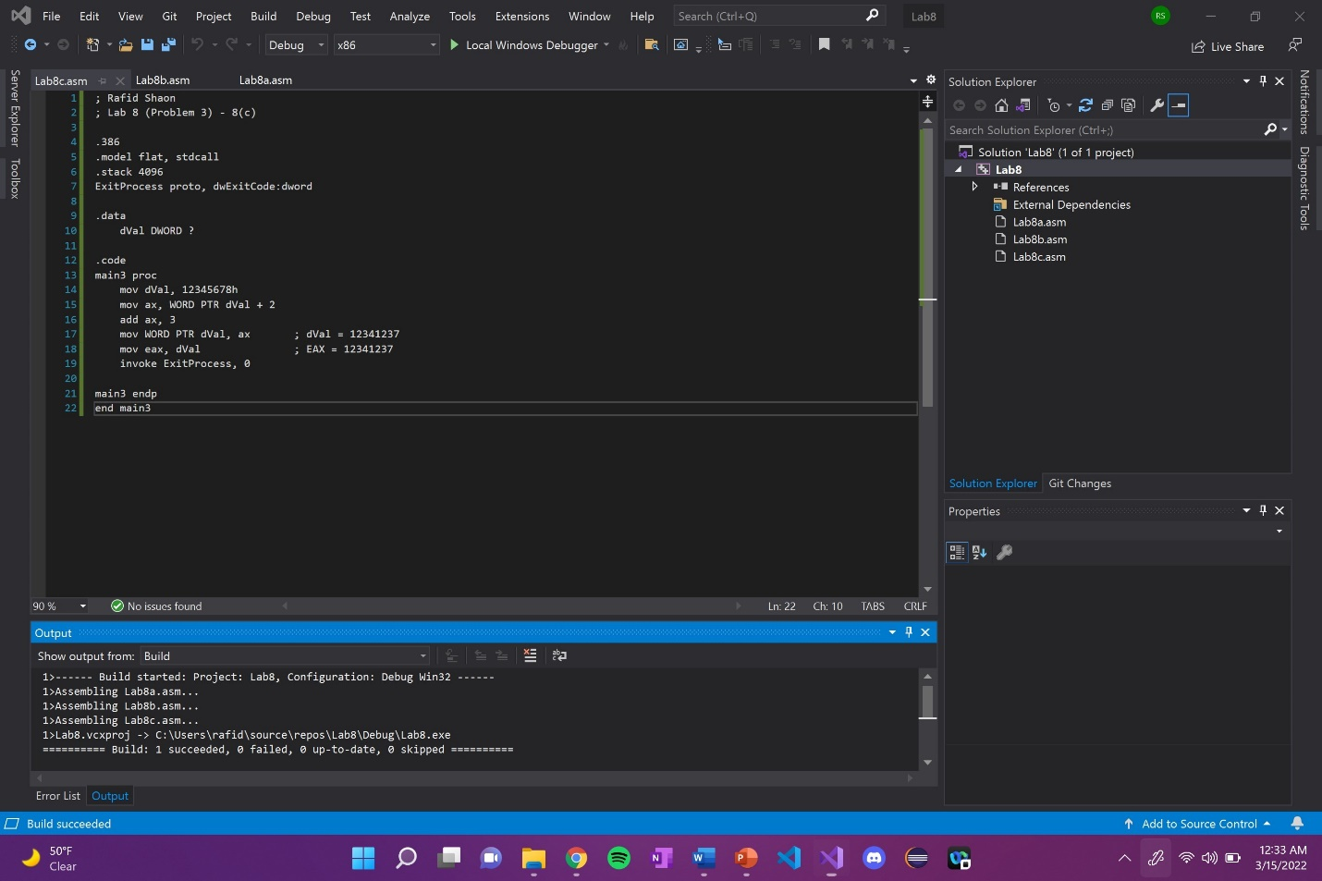

Line number: 14

Instruction: mov dVal, 12345678h

Register / variable content: EIP = 00B2108E, Memory 1 updated as well

Screenshot: 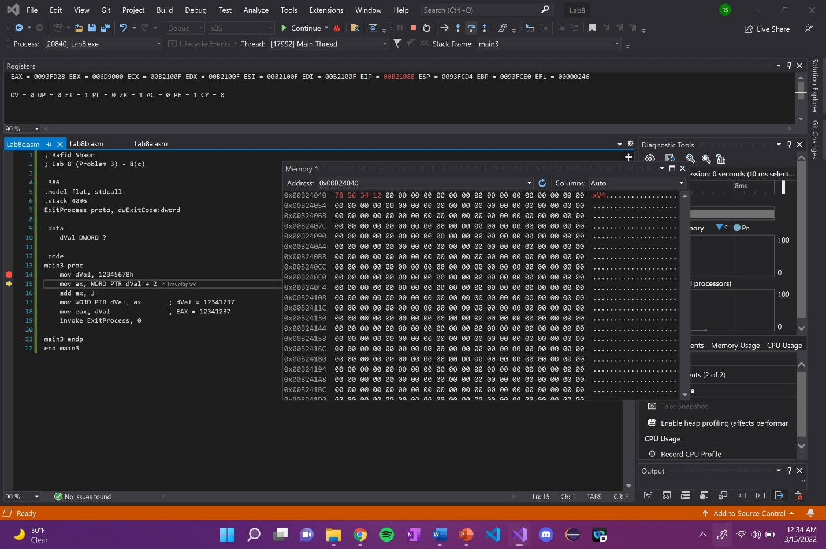

Explanation: Memory is updated from 0’s to 12345678h in Little Endian order when dVal was moved.

Line number: 15

Instruction: mov ax, WORD PTR dVal + 2

Register / variable content: EAX = 0093**1234**, No Memory 1 update

Screenshot: 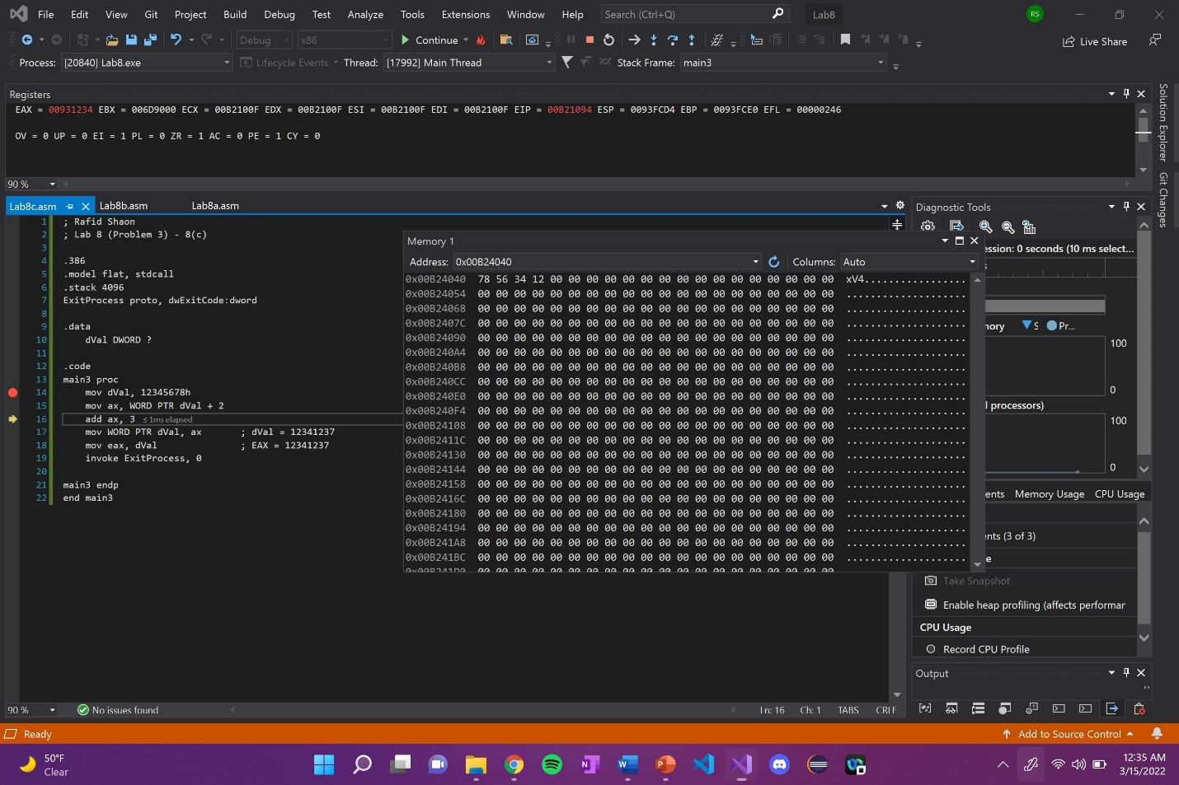

Explanation: AX in EAX register is updated with the values from dVal (**1234**5678).

Line number: 16

Instruction: add ax, 3

Register / variable content: EAX = 0093**1237**, No Memory 1 update

Screenshot: 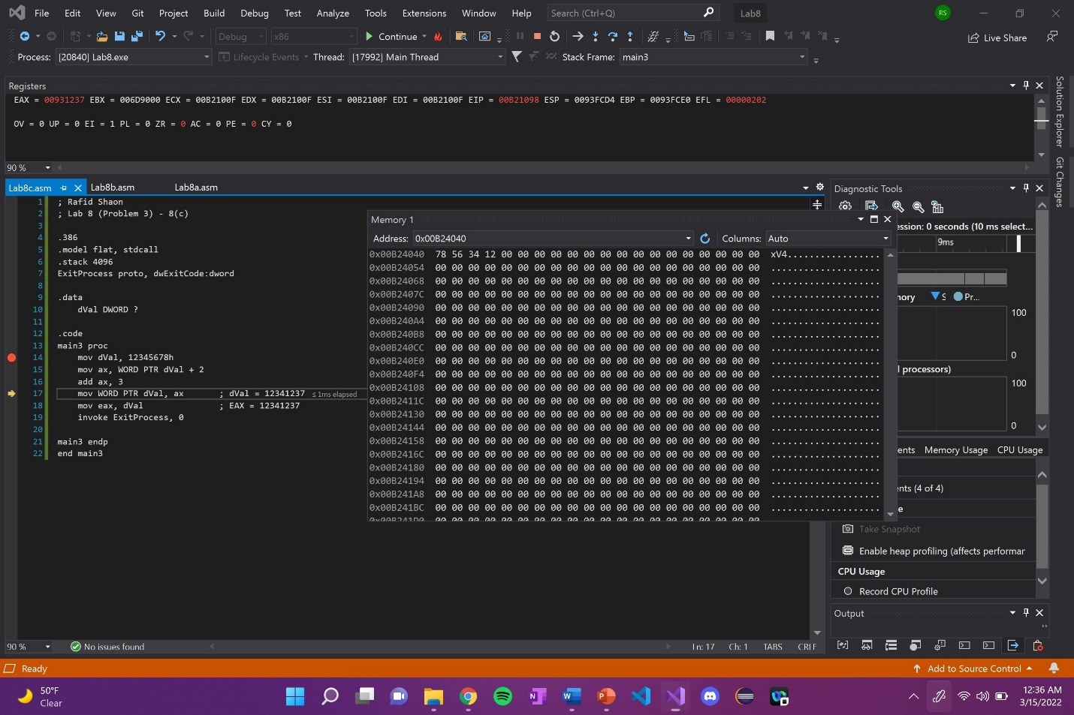

Explanation: 3 is added to AX in EAX register.

Line number: 17

Instruction: mov WORD PTR dVal, ax

Register / variable content: Memory 1 updated from 5678 to **1237**

Screenshot: 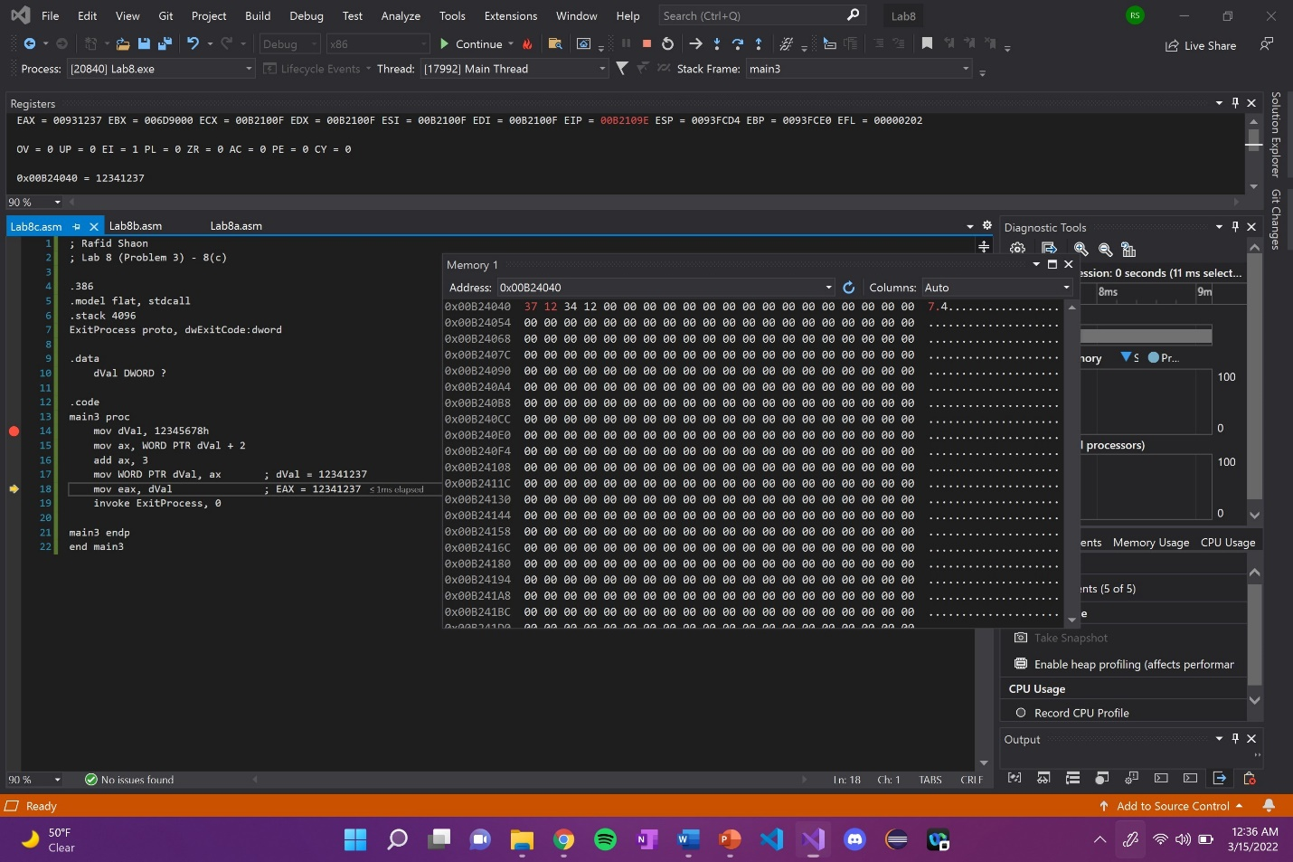

Explanation: The first two elements of Memory/dVal are updated with AX in Little Endian. The overall value of Memory is no **12341237**.

Line number: 18

Instruction: mov eax, dVal

Register / variable content: EAX = 12341237

Screenshot: 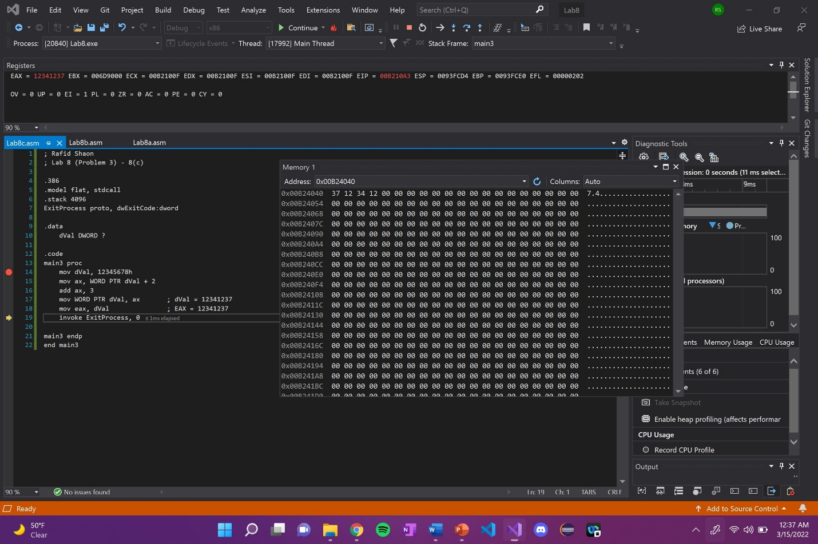

Explanation: EAX register is updated with the value in Memory/dVal.

(Copy this format as needed)

Lab 8(d)

Debug through each line of instructions.

Take screenshot that includes code and register window.

Record the register content.

and explain the register contents.

Code: 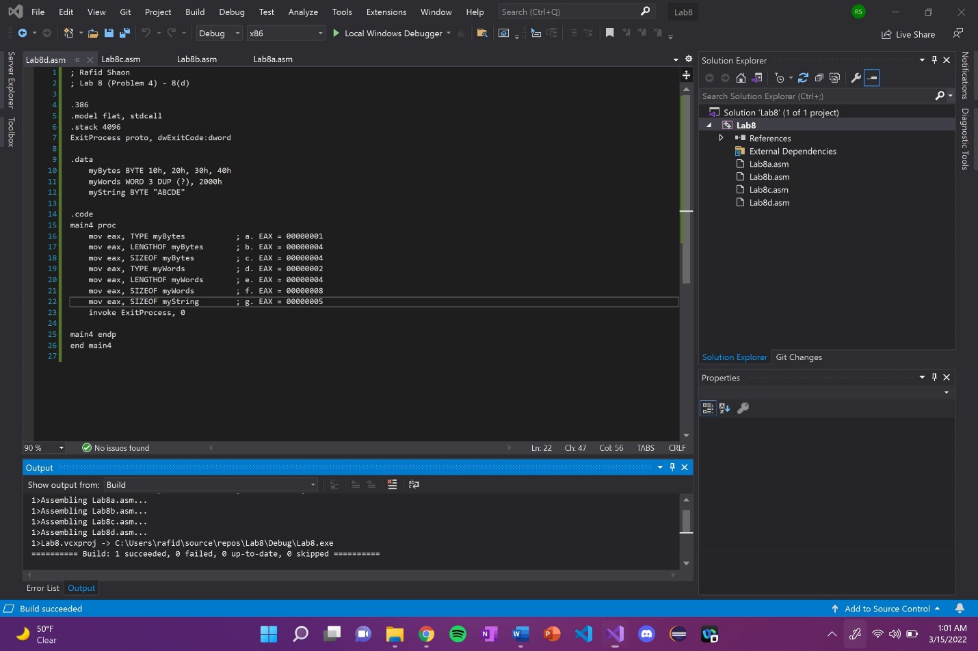

Line number: 16

Instruction: mov eax, TYPE myBytes

Register values: EAX = 00000001

Screenshot: 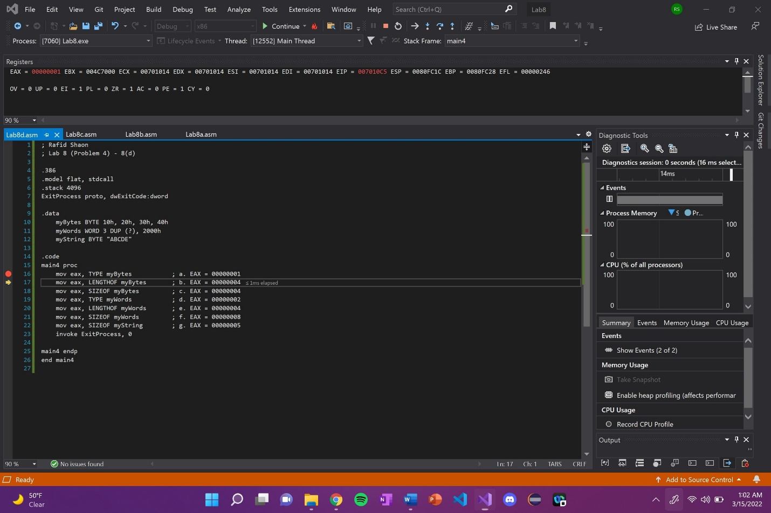

Explanation: EAX register is updated, returning with the size of myBytes (1 byte).

Line number: 17

Instruction: mov eax, LENGTHOF myBytes

Register values: EAX = 00000004

Screenshot: 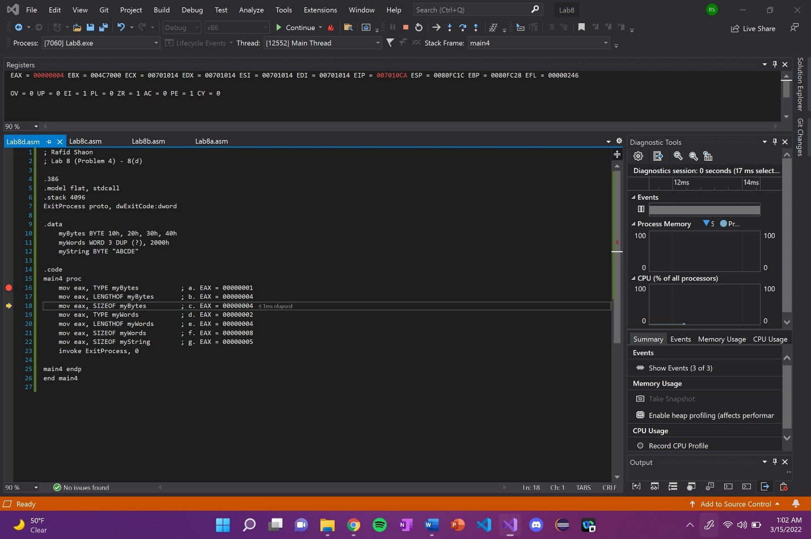

Explanation: EAX register is updated, returning the number of elements in myBytes (4).

Line number: 18

Instruction: mov eax, SIZEOF myBytes

Register values: EAX = 00000004

Screenshot: 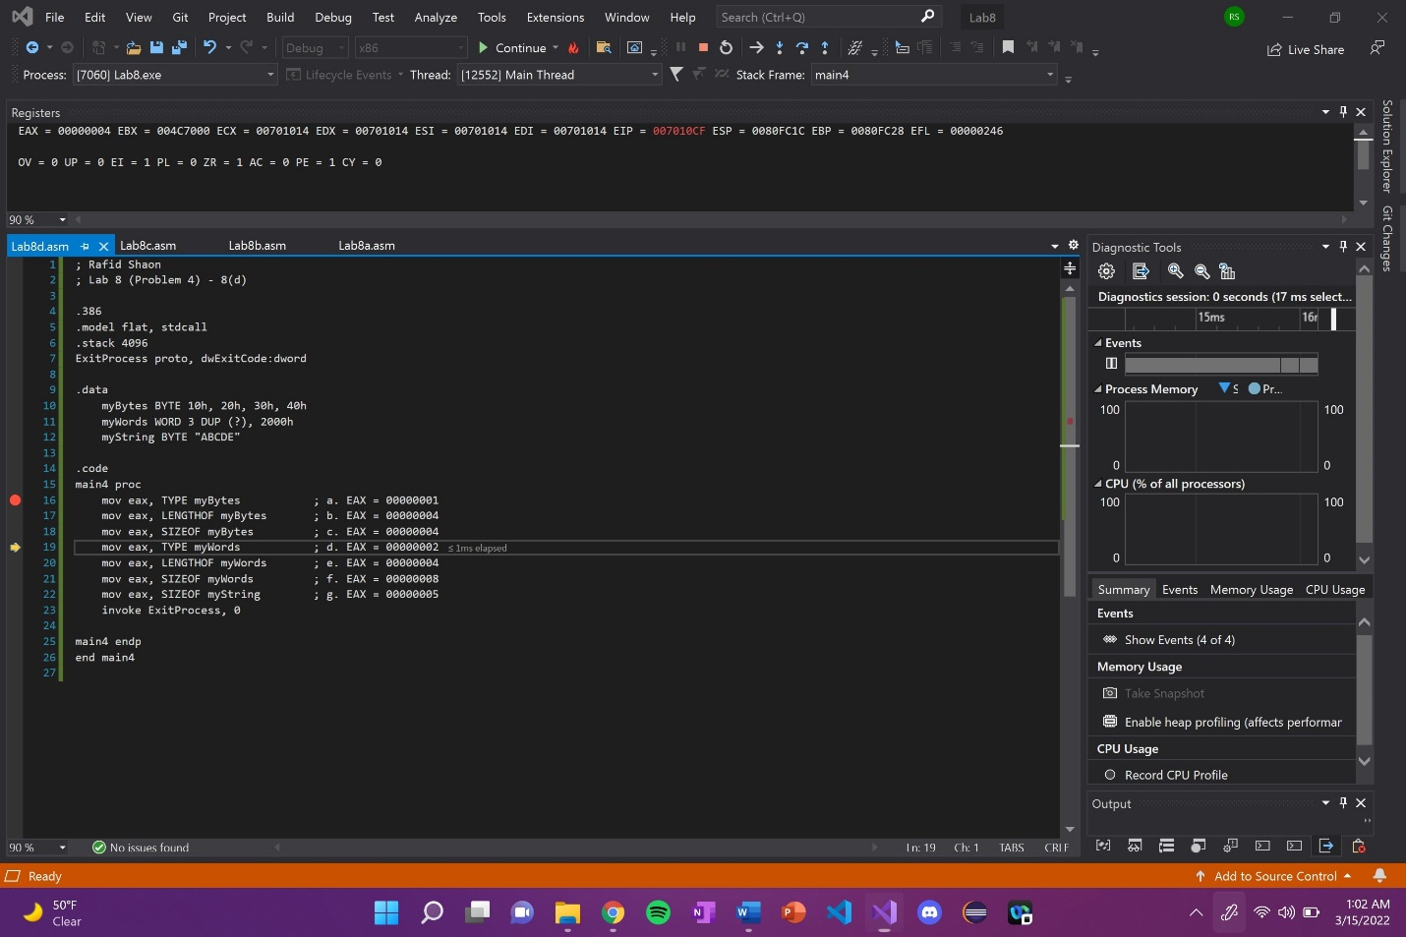

Explanation: EAX register is updated, returning the size of myBytes (4). In this case, EAX register did not change.

Line number: 19

Instruction: mov eax, TYPE myWords

Register values: EAX = 00000002

Screenshot: 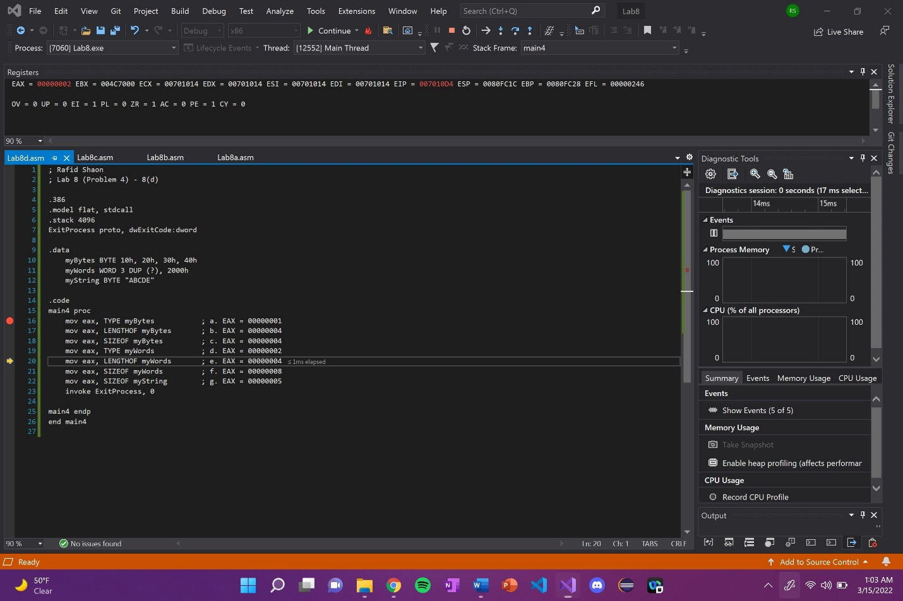

Explanation: EAX register is updated, returning with the size of myWords (2 bytes).

Line number: 20

Instruction: mov eax, LENGTHOF myWords

Register values: EAX = 00000004

Screenshot: 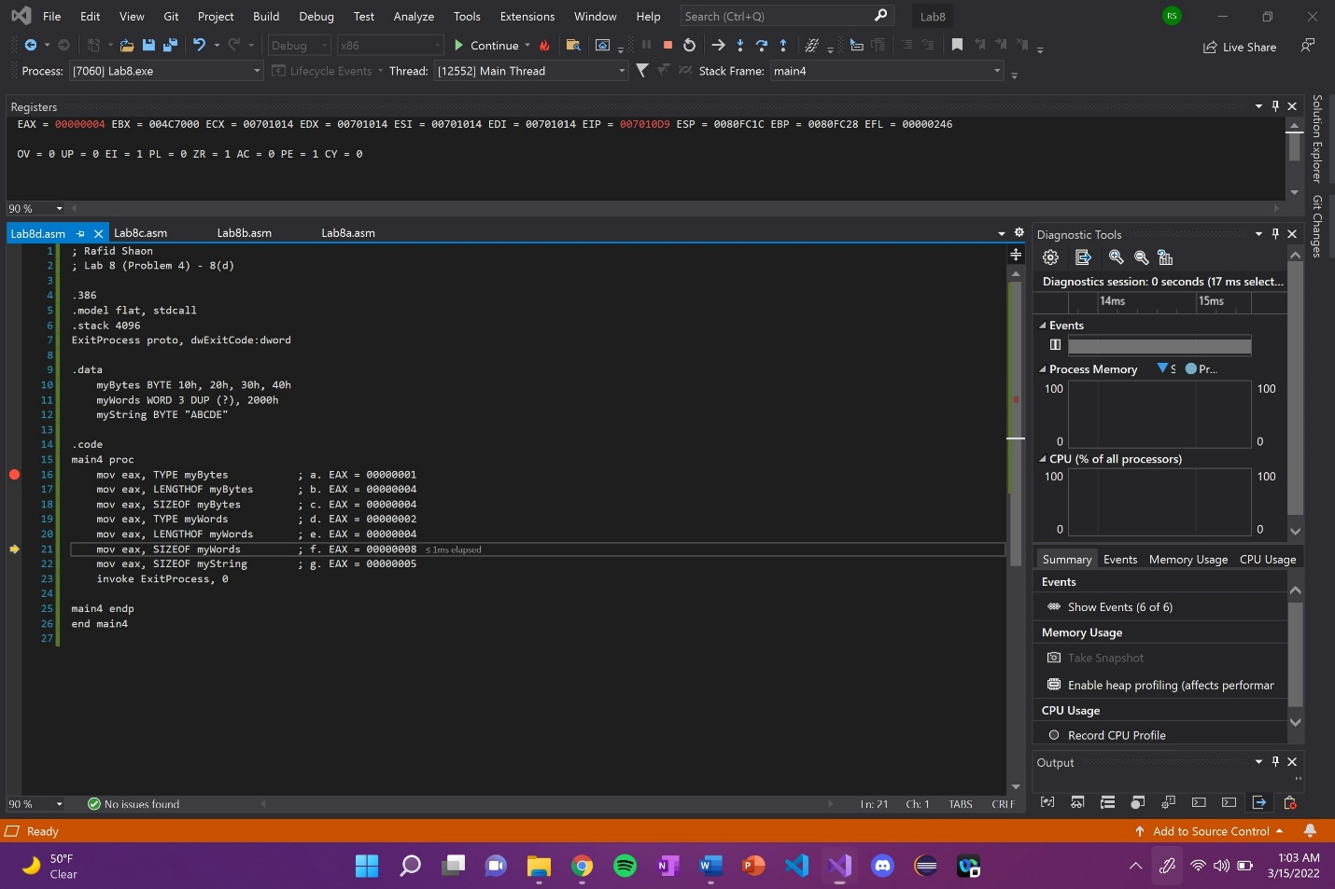

Explanation: EAX register is updated, returning the number of elements in myWords (4).

Line number: 21

Instruction: mov eax, SIZEOF myWords

Register values: EAX = 00000008

Screenshot: 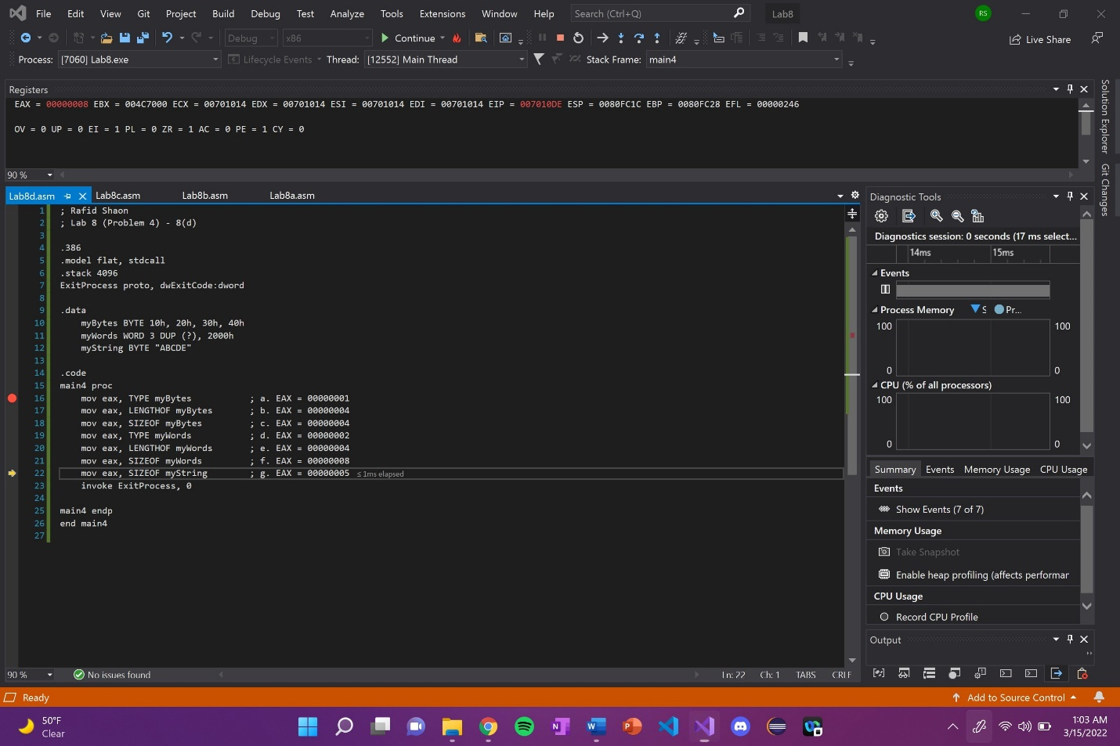

Explanation: EAX register is updated, returning the size of myWords (8).

Line number: 22

Instruction: mov eax, SIZEOF myString

Register values: EAX = 00000005

Screenshot: 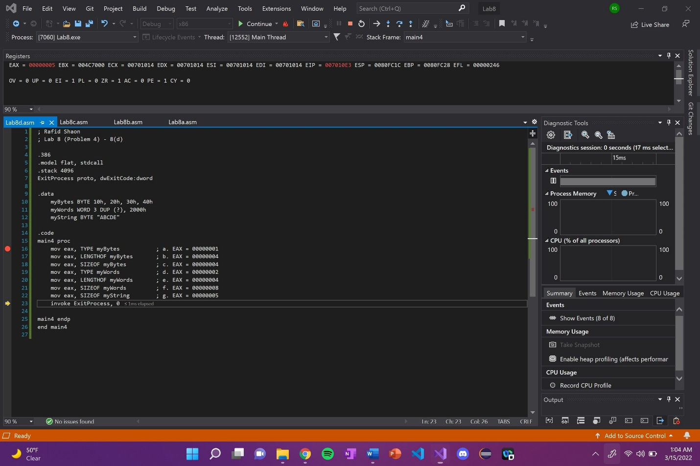

Explanation: EAX register is updated, returning the size of myString (5).

(Copy this format as needed)